Lab Experiments
SET -3
S. V. K. Sharon Surya
192324246

1.
# Employee Performance Dataset
employee <- data.frame(
Employee_ID = c(1,2,3,4,5),
Department = c("Sales","HR","Marketing","Sales","HR"),
Years_of_Service = c(5,3,7,4,2),
Performance_Score = c(85,92,78,90,76)
)

employee

# Line Chart
plot(employee$Employee_ID,
employee$Performance_Score,
type = "o",
col = "blue",
pch = 16,
lwd = 2,
main = "Employee Performance Trend",
xlab = "Employee ID",
ylab = "Performance Score")

legend("bottomright",
legend = "Performance Score",
col = "blue",
lty = 1,
pch = 16)
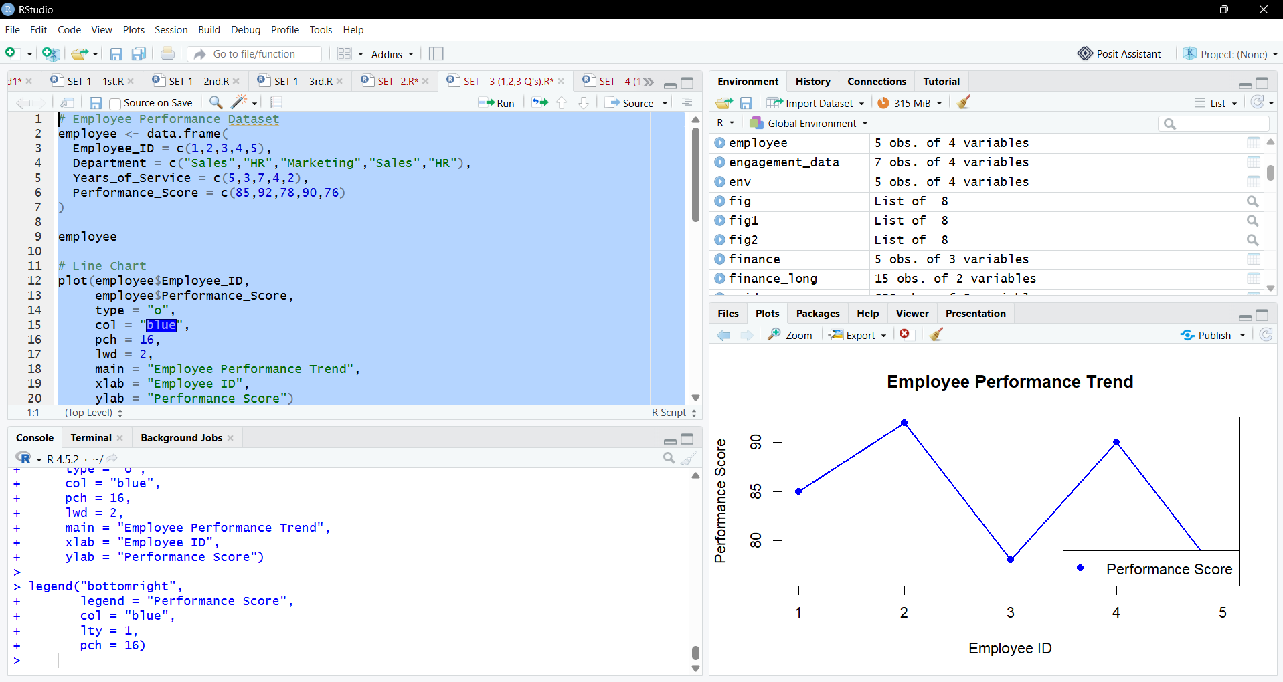

2.
# Count Employees by Department
dept <- table(employee$Department)

# Bar Chart
barplot(dept,
col = "lightgreen",
main = "Employees by Department",
xlab = "Department",
ylab = "Number of Employees")
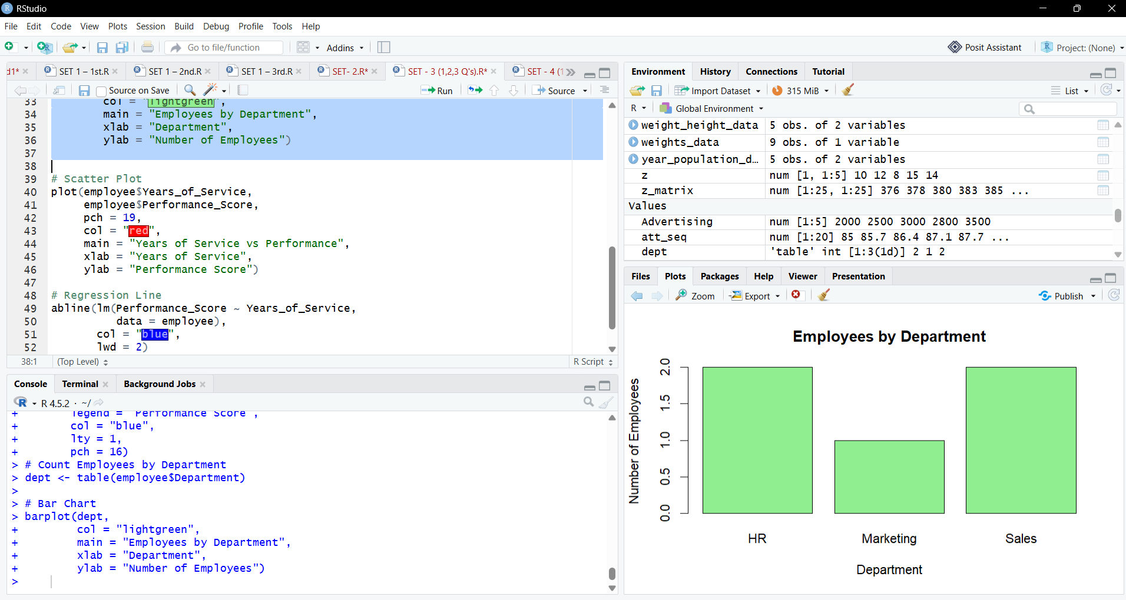

3.
# Scatter Plot
plot(employee$Years_of_Service,
employee$Performance_Score,
pch = 19,
col = "red",
main = "Years of Service vs Performance",
xlab = "Years of Service",
ylab = "Performance Score")

# Regression Line
abline(lm(Performance_Score ~ Years_of_Service,
data = employee),
col = "blue",
lwd = 2)

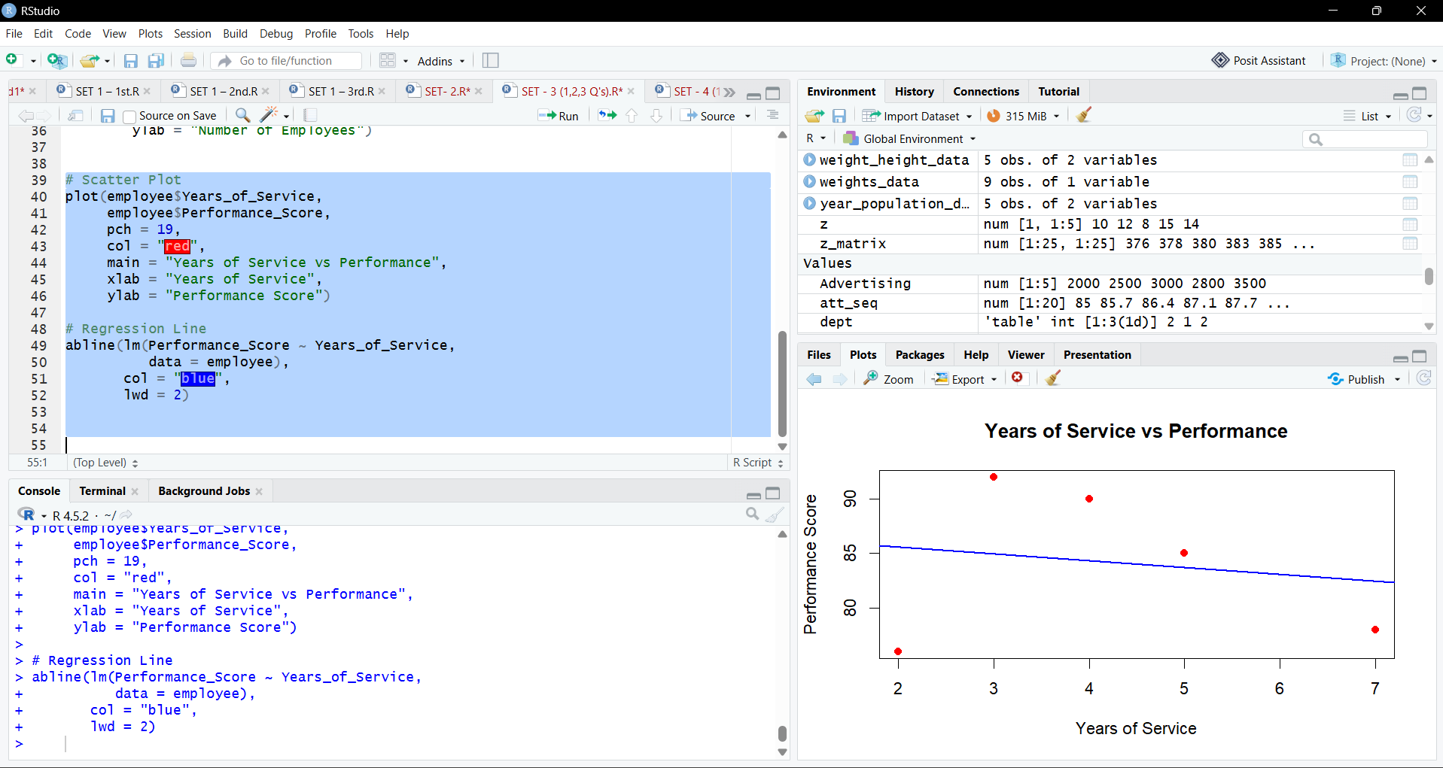

4.
